Medicine Bow Nordic Association
Summary of Activities and Long-Term Plan

MBNA Board of Directors,
July 27th, 2016

I. Introduction

The Medicine Bow Nordic Association is a non-profit (501 C3) organization that has groomed and maintained cross-country ski trails for public use from the Tie City Trailhead (Happy Jack area) east of Laramie since 1993, as authorized the U.S. Forest Service. Figure 1 shows the operating area for our activities, as established in the current cooperative agreement between the Nordic Association and the Forest Service. In this document, we describe our recent and current operations in the area, which we propose to continue as long they are mutually agreeable to the Nordic Association and the Forest Service. We also identify a number of refinements, re-routes, and extensions to the trail network that would allow the Nordic Association and the Forest Service to offer the maximum amount of high-quality, groomed-trail skiing possible in the operating area. To assist Forest Service managers in deciding whether the changes we propose can best be implemented incrementally or all at once, we provide a matrix that shows the improvements that will result from each change. Because every element in our plan will provide a measure of improvement, we would of course like to move forward quickly with as many elements as possible.

II. Background and Current Operations

The goal of the Medicine Bow Nordic Association is to provide and promote high-quality, easily accessible Nordic skiing to the people of southeastern Wyoming and northern Colorado. Our focus is the regular grooming of 15 kilometers of trails (Figure 1) specifically to maintain high-quality conditions for Nordic skiing. We typically groom the trails from approximately mid-November to mid-April. Some of these trails are used only during the winter and essentially do not exist outside of the ski season. Others are used during the snow-free times of the year as well for walking, running, bicycling, and horseback riding. The creation of groomed ski trails requires the initial clearing of trees, stumps, and brush to a width of approximately 12 feet to accommodate grooming equipment, and the removal of rocks that protrude through the snow. Periodic maintenance consists of removing fallen and hazardous trees and brush, and removing rocks that are gradually exposed by erosion during the summer and fall on trails used year-round.

The Nordic Association has also been deeply involved in development of a system of designated ungroomed winter trails (Figure 1). Maintenance of these trails consists only of removing fallen trees and snowshoe packing as resources permit, as approved by the Forest Service. We also post trail markers and maps on some of these trails.

Figure 2 shows the typical appearance in summer of the winter-only segments of the groomed trail network. Figure 3 shows the summer appearance of various segments of the groomed-trail network that receive both summer and winter use. Figure 4 presents examples of the summer appearance of ungroomed, winter-only multiple-use trails, which simply cease to exist under summer conditions. Other segments of the multi-use winter trails (not illustrated) are on previously-established summer-use trails.

In addition to grooming the Nordic trails, the Nordic Association organizes and teaches children’s ski classes (the WeeSki, KidSki, and Youth Ski Programs) as well as a Juniors program, a number of adult weekend and weekday classes and, in some years, a racing ski program. The network of Nordic trails that we groom is the training area for the Laramie Junior-High School and High School Nordic Ski Teams and the University of Wyoming Nordic Ski Team. In addition, these trails are used by some 290 Laramie 5th-graders each year as part of the public-school physical education program. We provide race-course grooming and marking services for local races sponsored by the Laramie Junior-High School, Laramie High School, and University teams, and by the Nordic Association. The Association and University races are open to participation by the public and typically draw strong support from the Laramie community. In 2012, Laramie hosted the Wyoming High School State Nordic Championships at the Tie City Trails, a 2-day event attended by approximately 200 competitors and as many spectators.

Although the Association relies on community volunteers for program supervision and planning, children’s ski instruction, and part of trail maintenance, funds from the Wyoming Recreational Trails Grant Program, the Albany Country Recreation Board, and the Albany County Commissioners have provided a critical supplement to membership dues and donations, and have greatly increased our ability to provide consistent, high-quality trail grooming and a well-coordinated program of public ski instruction.

Grooming of the ski trails is the sole responsibility of the Medicine Bow Nordic Association, but other aspects of the work required to develop and maintain the groomed ski trails and the ungroomed multiple-use trails are shared by the Forest Service. The construction of 5 kilometers of new trails in 2003 is an example. The Association's members saw the need for loop trails to supplement an existing section of out-and-back groomed Nordic trail to reduce congestion due to increased use and to connect existing groomed ski trails. We developed the initial design with periodic input from the Forest Service. A primary objective of the design was to minimize impact on the natural environment. Forest Service employees removed the trees and rocks from the new trail segments. The Nordic Association took responsibility for filling in the ruts and holes left by Forest Service trail-construction equipment and for the dispersal of cut trees and stumps. The Association holds an annual fall maintenance day for its members, and in some years, Forest Service sawyers help with removal of standing trees.

In 2002, the Forest Service built a warming hut at the Tie City Trailhead with design input and financial support from the Nordic Association. In 2005, the Forest Service constructed a new Summit Trailhead to provide better access to the Headquarters and Crow Creek trails, which are parts of the network of ungroomed, multiple-use trails. This new trailhead replaced a location that required a 200-yard hike over bare ground to get to skiable snow. The Nordic Association and the Forest Service worked together in designing the new location to ensure good access to ski trails.

In 2011, the Nordic Association constructed a building near the Tie City Trailhead to store all of our equipment on-site and out of the weather year-round. We worked with the Forest Service in locating and designing the building to minimize its environmental and visual impact and to make it compatible with existing Forest Service structures.

In 2014, the Nordic Association and the Forest Service designed and constructed a new segment of the groomed Blackjack Trail. This new segment is a winter-use-only trail and replaces a segment of the trail that was groomed in winter and used in summer, and that replaced segment became part of the ungroomed multiple-use trail network. At the same time, the Forest Service constructed a new, winter-only, ungroomed trail to connect the Middle Aspen and Aspen trails. Both of these projects connected large segments of the winter multiple-use trails to provide loops that do not overlap the groomed Nordic trails.

The Nordic Association and the Forest Service have jointly produced and distributed ski-trail maps that include education and trail etiquette information. The maps were designed by the Nordic Association and the Forest Service. The Nordic Association paid the printing costs and distributes the maps.

The Tie City Trails are the best-maintained Nordic ski trails easily accessible to the people of southeastern Wyoming (including the state's largest and third-largest cities) and the Colorado Front Range. Recreational opportunities such as those provided by the Medicine Bow Nordic Association are one of the amenities used to promote employment in Laramie and recruitment for the University of Wyoming. To quantify trail use, we maintain a trail counter near the Tie City Trailhead during the ski season, beginning as soon as there is sufficient snow for grooming in the fall and ending in the spring when grooming becomes impossible. Figure 5 presents a typical year’s data on round-trips (out and back) logged through this trailhead. The annual pattern is one of peak use on race days and on weekends, and during large-attendance classes. Annual totals vary widely in response to snow conditions, but we have documented an increasing trend over 11 years (and continuing) of numerical monitoring. The 2009/2010 ski season (an exceptionally snowy winter) set a record with over 34,000 skier round trips.

III. Long-Range Plans

A. Permitting

The Medicine Bow Nordic Association grooms and maintains the Tie City Trails under a challenge cost-share agreement with the U.S. Forest Service that currently extends through 2018. Under that agreement, we provide to the Forest Service annual operating plans describing the activities that we intend to undertake during each year. Our ski classes and races are currently conducted under terms of annual special-use agreements.

Attachment A provides our 2015-16 Annual Operating Plan and the most recent editions of the ski-trail and multi-use trail maps. We anticipate that operating plans in future years will differ little from this one.

B. Grooming and Trail Maintenance

We anticipate no substantive changes to these activities. As in past years, we will commence grooming the Nordic trails as early in the season as snow conditions permit, groom regularly throughout the season as necessary to keep the trails in good condition for skiing, and groom as far into the spring as snow conditions permit and skiers show interest in using the trails. We will continue to hold a trail maintenance day in the fall for volunteers to get the trails into shape for grooming. As conditions require, we will remove fallen trees and hazardous standing trees before and during the ski season. And we will continue to work with the Forest Service and other groups to maintain and promote the ungroomed multiple-use trails.

Although no specific program has been developed at this point, we emphasize the need for maintenance and rehabilitation of some of the summer-use trails which are also groomed for skiing in the winter. We would be pleased to work with the Forest Service and other trail users to accomplish this.

C. Classes and Races

As with trail maintenance and grooming, we anticipate no substantive changes to our educational classes or our support of races. We will continue to offer a variety of classes to skiers of all ages and abilities, to conduct a few races of our own each year, and to support the races held by the Laramie Junior-High School, Laramie High School, and University of Wyoming teams.

D. Additional Development of the Groomed-Trail Network

Figure 1 shows the current system of trails that the Nordic Association grooms for Nordic skiing. We are proposing modifications to these trails to re-route some segments around rocky or windblown areas, to make our grooming more efficient, to add trails suitable for use by beginning skiers, and to allow for a greater variety of race courses.

Portions of the groomed Nordic ski trails follow existing summer-use trails and others receive only winter use. The latter trail segments are so obscure once the snow melts that most summer users of the Tie City area are unaware of them. Groomed-trail skiing requires clearance of trees and brush to a width of 12 feet to accommodate grooming equipment, but otherwise has no impact on the ground surface, which remains stable, well-vegetated, and productive (see Figure 2). Ski trail signs are removed at the conclusion of the ski season so that summer use is not encouraged. Experience to date shows that the winter-use-only trails receive little or no use in summer. Where we propose to move the groomed trails off of summer-use trails to avoid their rocky and eroded character (e.g. see Figure 3), we do not mean to suggest that the summer-use trail alignments be adjusted in any way. Nor do we propose to reclaim any of the summer-use trails. We will simply stop grooming them in the winter.

All new trail segments will be treated as are the other parts of the groomed trail system: trees and brush will be cleared to a width of 12 feet, trails will be mapped and marked with signs to indicate direction of travel and degree of difficulty, and the ground vegetation and soil surface will be left undisturbed.

To present the proposed modifications, we have divided the trail system into a group of inner loops (Figures 1 and 6) and a second group of outer loops (Figures 1 and 7). Modifications to the inner loops are described in section 1 below and modifications to the outer loops in section 2. In section 3, we group together modifications that we think could be made more or less at the same time, and assign priorities to those groups. See the ski-trail map in Attachment A for the names commonly used for the individual trail segments.

Table 1 shows the effects that each change would have on the overall quality of skiing and on four aspects of trails use, and the net increase or decrease in the grooming resources (primarily time and fuel) we expect. The table also shows the relative size of the change, an estimate of the number of trees to be cut, and whether the work could be done by the Nordic Association or would require work by the Forest Service.

Note that none of these changes that we propose would (1) affect the summer use of existing trails, (2) create new summer-use trails (and hence would not result in damage to the soil cover), or (3) disturb wildlife outside of the ski season. The work to be done on each of these changes is only the removal of enough trees in each case to allow passage of grooming equipment (which requires a width of 12 feet). In each case, the route would be determined in detail on the ground, so that the minimum number of live trees would be cut.

The requested improvements are grouped by general priority, determined by both the ease of accomplishment and the subsequent change (increase or decrease) in required grooming resources.

Modifications and Additions to the Inner Loops

Based on many years of daily grooming under a wide variety of snow conditions and user traffic, and careful observation of snowfall and accumulation patterns, we have identified 17 places on the inner loops where minor modifications to the trails will improve skiing and grooming and also lengthen the ski season. The purposes of these modifications are to:

1) avoid areas that melt out early in the spring;

2) avoid areas that are badly windblown in the spring or during low-snow years and therefore prevent skiing on otherwise well-covered trails;

3) avoid prominent rocks that are dangerous to skiers and are obstacles to grooming;

4) avoid areas that are badly eroded and rutted, making grooming difficult, particularly in thin-snow years;

5) provide for a trail somewhat longer and less prone to sun exposure of rocks;

6) eliminate two-way traffic; and

7) expand the trail system to accommodate additional use and teaching/racing opportunities.

An initial survey of these changes was made with the Forest Service's Realty Specialist Nathan Haynes in November 2012, at which time locations were recorded with a GPS receiver. We are prepared to mark any of the suggested changes on the ground when requested to do so by the Forest Service.

These changes are described below. Their locations are shown on Figure 6.

Changes 1 & 2 – Move short sections of Alder Trail off the deeply eroded summer trail by cutting trees along the south side of the trail so that the groomed winter trail can be moved slightly, or by rerouting the groomed winter trail through the trees farther to the south of the summer trail.

Change 3 – Groom a route through tree-free, sagebrush and grass vegetation to connect the Lower Meadow with the Campground Loop. No trail clearing would be required. Part of this proposed new route is routinely used by the Nordic Association's groomers to reach the fuel tank, and the remainder has been used by skiers and spectators to reach the race start area in the Lower Meadow without walking down the main ski trail. This new piece of trail would create several options for shorter race loops that can be used for citizen, junior, high school and college races. It would also allow race organizers to keep race courses off the heavily used trails at the beginning of the trail system. Finally, it would provide options for young skiers in our Weeski and Kidski programs to get onto interesting trails much closer to the warming hut and also reduce the congestion on trails near the trailhead on Weeski and Kidski days.

Change 4 – Re-establish a previously-groomed but now unused ski trail between the Lower Meadow and the Alder Trail. This change involves clearing downed trees from the unused trail and widening it slightly. As with Change 3, this trail would provide additional near-trailhead options for races and our Weeski, Kidski, and Junior programs and the junior-high school and high school programs.

Change 5 – Clear a long-abandoned road between the Lower Meadow and the main Meadow. This change would require removing aspen trees that have grown up in the route and widening it in places by removing mostly beetle-killed pines. As with changes 2 and 3, it would provide more near-trailhead terrain for racing, the Weeski, Kidski, and Junior program, and the junior-high and high school teams.

Change 6 – Avoid large rocks on the left-hand and right-hand sides of the trail at the north end of Lower UW by shifting the trail to the east.

Change 7 – Re-route a section of Roller Coaster Trail to avoid large rocks, areas where snow is scoured in most winters, and areas that melt out early in the spring.

Change 8 – Eliminate the steep, south-facing hill on Lower UW. This short section melts out much earlier in the spring than does the rest of the trail, rendering Lower UW unusable even when virtually all the rest of the trail is still covered with snow. The new route winds to the left up a shaded draw until it joins an abandoned road that in turn joins the existing ski trail at the top of the hill.

Change 9 – Extend Roller Coaster Trail by creating a new section of trail that turns southeast toward Lower UW, instead of turning west into Ridge Trail. The new trail would drop downhill and southeast, then turn back uphill to meet the Lower UW and Phil’s Pholly trails at a common point south of the start of the multiple-use Aspen Trail. This change would create a longer Roller Coaster Trail, and eliminate 2-way traffic on the southern section of the Ridge Trail.

Change 10 – Reroute a short section near the southern end of Ridge Trail to the west. This would eliminate a windblown, rocky section of trail that melts out early in the spring and prevents grooming and skiing on the rest of Ridge Trail.

Change 11 – Abandon the eroded, rocky, outbound side of the steep Elevator Hill at the south end of the Meadow Trail (see Figure 3B) and move the trail further to the south where it is more protected and gentler. This would eliminate a section of trail with two-way traffic and reduce congestion on the trail where skiers approach the south end of the Meadow.

Change 12 – This change would move the beginning (outbound) of Lower UW Trail and the end (inbound) of Phil’s Pholly to a common point to the south of the head of the multi-use Aspen Trail. The new inbound end of Phil’s Pholly would follow one of 2 existing but unused routes. The outbound end of Lower UW would be a new piece of trail created through the trees to join the existing Lower UW Trail, near the head of the multi-use Aspen Trail. In combination with change #13, this would improve circulation and reduce the confusion that skiers experience at the existing junctions.

Change 13 – This change would create a second entrance to Phil’s Pholly (in addition to the existing one off the Upper UW trail). A short segment of inbound Phil's Pholly would be abandoned as part of change 12, isolating the very end of inbound Phil's Pholly. That isolated portion would be connected to outbound Phil's Pholly by a short piece of new trail through a sparsely-treed area. This extends Phil’s Pholly by 0.25 miles with little impact on the forest and makes it possible to ski 100% of the groomed trails in one continuous loop for a race or training without backtracking or facing two-way traffic. This also makes grooming more efficient, by eliminating double-grooming on the end of Upper UW.

Change 14 – Move a short section of the north side of Phil's Pholly (the inbound side) slightly to the south to avoid a large rock that is exposed much of the time in most winters. This re-route would require cutting trees on the south side of the existing trail.

Change 15 – Reroute a section of the outbound (west) side of Upper UW to the east, to move the groomed winter trail off of the rutted summer trail.

Change 16 – Move the north-facing “Caution Hill” on Upper UW to the east, to avoid the rocks exposed by severe erosion of the summer-use trail.

Change 17 – Replace a short, windblown section on the north side of Gobi’s Loop with a longer trail farther to the north. This change would eliminate a segment of the trail from which the snow is blown away almost every winter, and also lengthen Gobi's Loop.

2. Modifications and Additions to the Outer Loops

The following proposed changes are shown on Figure 7.

a. Trail re-routes

Change 18 – Summit Road Re-route. Abandon the eastern 0.46 km of Van’s Loop (from Van’s Cutoff to the beginning of the Summit Loop) and build a new winter-use trail segment to the north, on the north side of the existing fence line. This would move the groomed winter trail off of a section of the summer trail (the old Summit Jeep Road) that is badly eroded due to heavy summer traffic and poor drainage (see Figure 4C). Also, the road in this section is concave, making grooming difficult unless the snow is unusually deep.

Changes to the Summit Loop

Currently, the Summit Loop (2.0 km out of the 15 km of total groomed ski trails) cannot be groomed during low-snow years and during the early and late parts of most ski seasons due to a number of sections of the trail that are badly eroded or windblown. We propose three substantial modifications that would abandon 1.4 km of the existing trail and establish 1.8 km of new trail. These changes would essentially create a new Summit Loop 2.4 km long.

Change 19 – Summit Loop Reroute - North. Abandon the rocky, open, windblown segment (“Hurricane Pass”) on the north end of the Summit Loop and replace it with new winter-use trail in the trees to the north. This would eliminate one segment that melts out early, a second segment where snow drifts deeply, and a third segment of steep downhill trail where strong winds remove snow and expose many rocks.

Change 20 – Summit Loop Reroute - Southwest. Abandon the existing winter trail on the old, eroded Summit jeep road (see Figure 3D) from the beginning of the Summit Loop to Brown’s Landing and replace it with new winter-use trail northeast of and parallel to the existing trail.

Change 21 – Summit Loop Reroute - East. Abandon a section of winter trail on the easternmost part of the existing loop that lies on the badly eroded old jeep road, and replace it with new winter-use trail slightly to the east.

b. Summit Loop Expansion (new loops)

The most recent ski trail expansion at Happy Jack occurred in 2005. Since the Nordic Association first started keeping records during the 2005/2006 ski season, trail use has increased significantly (with some variation due to low snow years and/or short ski seasons). Foot traffic, snowshoe use, and snow bike use have also increased. Most of the terrain in the Tie City / Happy Jack area where Nordic ski trails can be constructed and groomed has now been developed.

We have, though, identified two areas where new loops of groomed Nordic trails could be developed. These are shown on Figure 7. Wherever possible these trails would follow natural openings in the forest or would involve the removal of dead trees only. Live trees would be removed only when necessary, with aspens selected for removal before pines and small trees before large trees. Construction of these two new loops, combined with the rerouting of the existing Summit Loop as described above, would increase the length of groomed Nordic trails in the Tie City - Happy Jack area from the current 15 km 16.9 km.

Loop A would extend southwest from the southwestern side of the Summit Loop. It would be 1 km long.

Loop B would extend from the southwestern end of Loop A, also to the southwest. It would be 0.5 km long.

3. Summary of Benefits and Priorities For Proposed Modifications to the Inner and Outer Loops

While no specific timeline is proposed for these trail modifications, we are prepared to and would like to proceed as soon as we can secure Forest Service approval, on either a trail-by-trail or total-project basis. By way of priority, the proposed trail adjustments are listed here in groups, with the groups in order from highest priority to lowest. The benefits from each modification are identified in Table 1.

Priority 1: Segments 1, 2, 6, 10, 11, 12, 13, 14, and 16 are requested primarily to improve skier safety and to reduce the wear and tear on grooming equipment from exposed rocks. All of these adjustments are relatively small and could be accomplished by Nordic Association employees and volunteers as part of our routine trail maintenance and tree-removal activities.

Priority 2: Segments 8, 9 and 15 are requested to extend the ski season by avoiding sun and wind damage and to improve grooming efficiency by promoting continuous one-way loops. These adjustments are primarily along previously-used trails or in areas with few trees and could be accomplished by Nordic Association employees and volunteers as part of our routine trail maintenance and tree-removal activities.

Priority 3: Segments 7, 17, 18, 20, and 21 involve more extensive re-routes, aimed at general improvement of trail conditions, improved circulation patterns, or limited expansion of trail mileage. Forest Service coordination and assistance would be very helpful in these cases.

Priority 4: Segments 3, 4, 5, 19, Loop A, and Loop B involve major re-routes aimed at avoiding serious erosion on summer-use trails and at expanding the groomed ski trail-network into limited new areas. Forest Service coordination and assistance would be required in these cases.

E) Multiple-Use Trails

In the past several years, we have seen substantial increases in use of the groomed Nordic trails by people hiking, snowshoeing, running, and snow biking. This increase in use by non-skiers has increased both the effort necessary to maintain a good skiing surface and conflicts between skiers and others over the appropriate use of these trails that the Medicine Bow Nordic Association grooms specifically for Nordic skiing. It also has raised concerns about safety. In an attempt to maintain the quality of skiing and prevent an increase in the number and severity of conflicts, we have increased our efforts to provide a system of ungroomed multiple-use trails as a more-attractive alternative for people seeking well-established and well-marked winter-use trails, but who neither need nor want the wide, flat trails necessary for skate skiing. These trails are shown in Figure 1 as the "Ungroomed" trails.

These efforts by the Nordic Association began in 2007, when we marked a short snowshoe trail along the western side of the groomed ski trails. In 2011, at the request of the Forest Service, we began putting up and maintaining trail markers on the Crow Creek Trail. In 2012, we received a grant from the Albany County Recreation Board to do additional work on the Crow Creek Trail during the 2012-2013 season. This work consisted of packing the snow on the trail, producing maps of the multiple-use trails, and posting signs with maps at trail intersections. That work was well received, and was consequently extended to the Pole Creek, Middle Aspen, Aspen, and Haunted Forest trails in 2013-2014.

Early in 2014, the Nordic Association worked with commercial interests and other user groups to develop the January 14, 2014 “Happy Jack Winter Trails Cooperation Agreement”. This document laid out a framework for the multiple use of the winter trail network. It was signed by representatives of the Medicine Bow Nordic Association, High Plains Harriers Running Club, Laramie BikeNet, the University of Wyoming Outdoor Program, The Pedal House, All Terrain Sports, and Cross County Connection.

As described above in section II, the Forest Service subsequently (in summer 2014) improved the multiple-use trail system further by construction of a replacement for part of the groomed Blackjack Trail and a new multiple-use trail connecting Middle Aspen Trail to Aspen Trail.

Our work to develop and promote the multiple-use trail system for non-skiers has been guided by: 1) the desire to disperse winter use across a larger winter trail network; 2) the desire to minimize conflicts between groomed-trail skiers and other users; 3) the recognition that narrower trails provide a more enjoyable experience for most snowshoers, hikers, bikers, and runners; 4) the recognition that loops and trails of varying length create more attractive opportunities; and 5) a desire to minimize the number of intersections with the groomed ski trails and to establish the necessary intersections at points where skiers are traveling slowly and where skiers on the groomed ski trail and people on the multiple-use trail have good lines of sight. It's important to note that the development of the system of multiple-use trails has been a cooperative effort of the Nordic Association, other user groups, and the Forest Service.

As resources permit, the Nordic Association proposes to continue packing, marking, and mapping these and other Forest Service-approved multiple-use routes, to improve opportunities for other users, to reduce the impacts of non-skiers on the groomed trails, and to enhance the safety of all winter trail use. We will continue working with other user-groups in this effort.

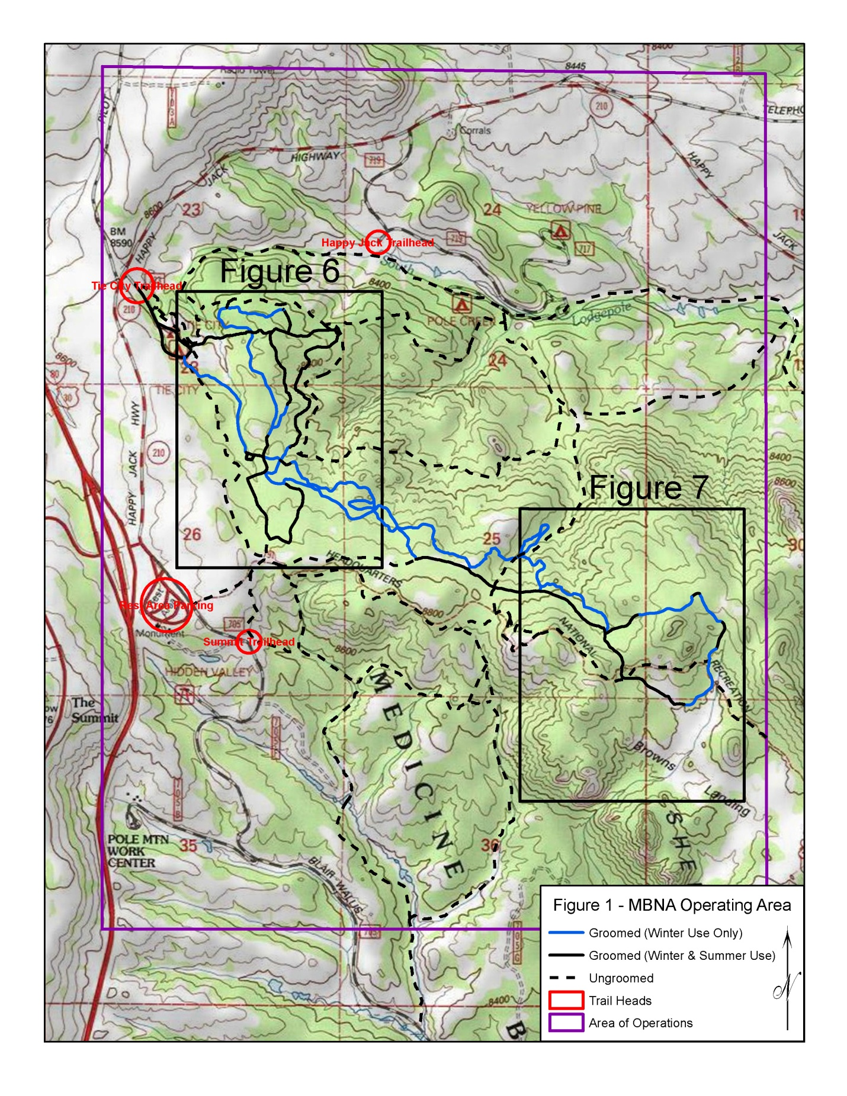
Figure 2. MBNA-groomed trails with winter use only. Resource impact is limited to tree and brush removal to accommodate over-snow grooming equipment. There is no ground disturbance.
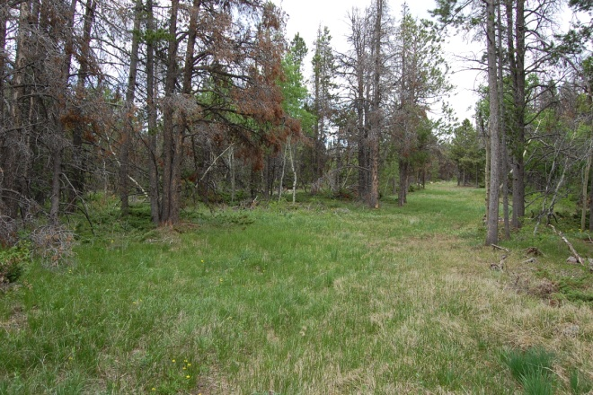
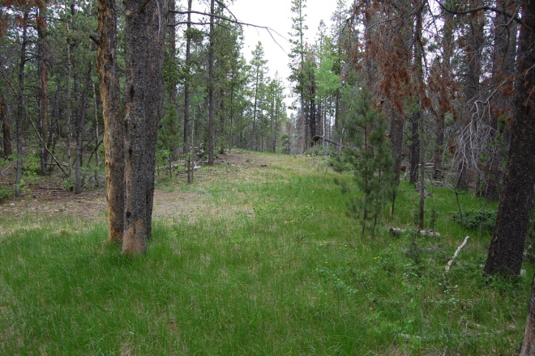
A. Outbound Moose ski trail B. Outbound Phil’s ski trail

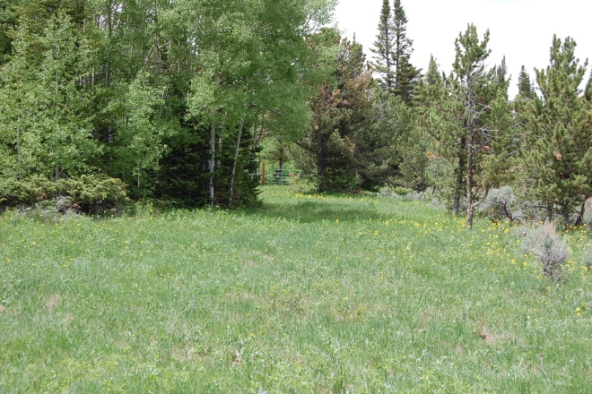
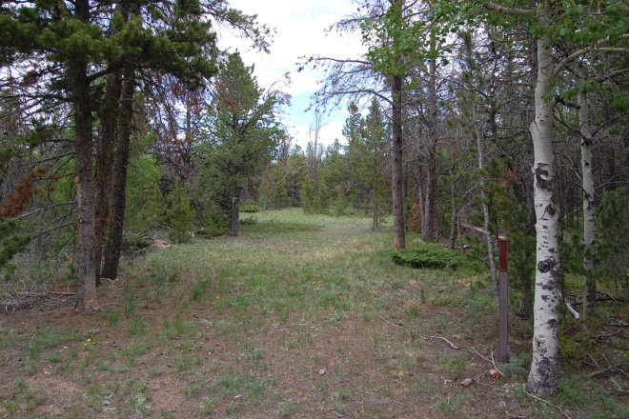
C. Intersection of Upper UW and Phil’s D. Start (north end) of Meadow ski trail
Pholly ski trails

Figure 3: Segments of summer-use trails that are groomed in winter. These previously developed summer-use trails (and old roads) have been altered for ski use just by selective tree and brush removal to accommodate over-snow grooming equipment. Summer-use impact varies from single-track definition to significant erosion.
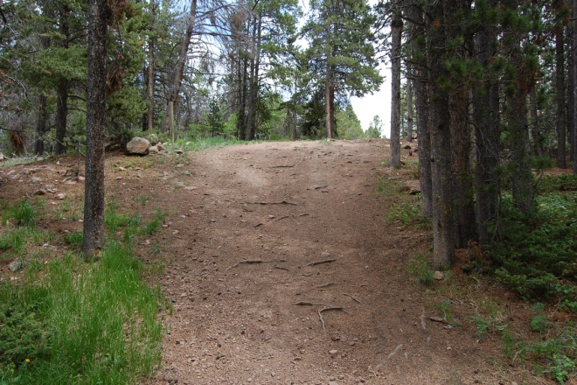
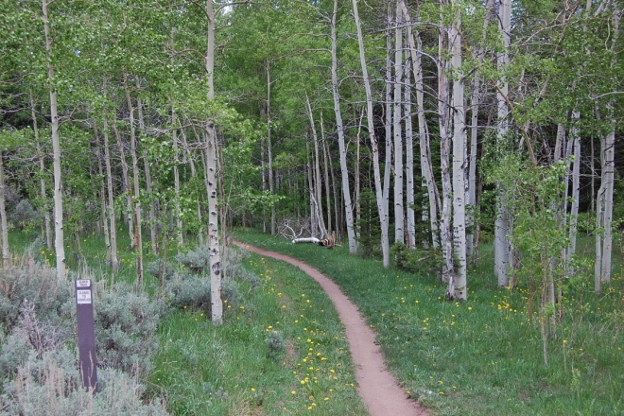
A. Start (west end) of Alder Trail B. Elevator Hill at south end of Meadow
Trail, outbound
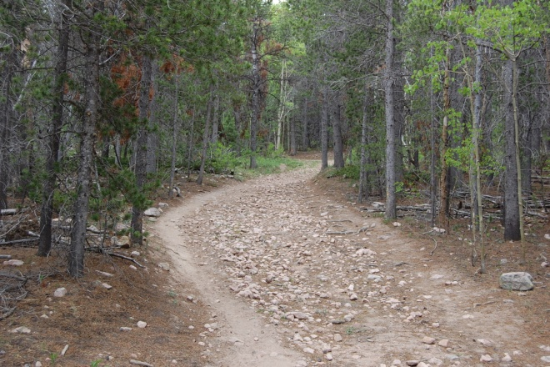
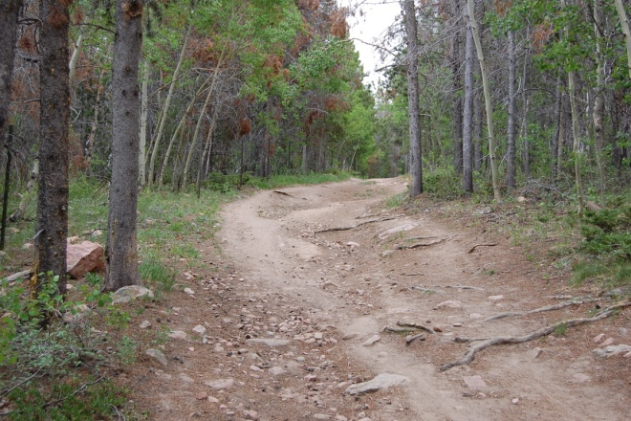

C. Van's Loop, outbound, on the summer D. Start of Summit Loop, on old jeep trail
Summit Road

Figure 4. The Snowshoe Trail and other multiple-use winter trails are marked and mapped by MBNA. Some are winter-only routes; some follow summer-use trails. Winter use involves no impact except removal of down trees. Note small trail markers (yellow, blue) at center left in each photo.

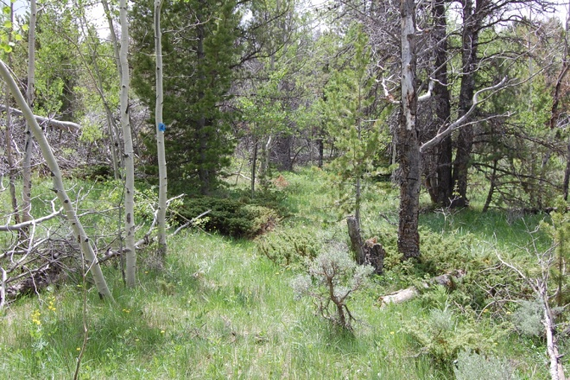
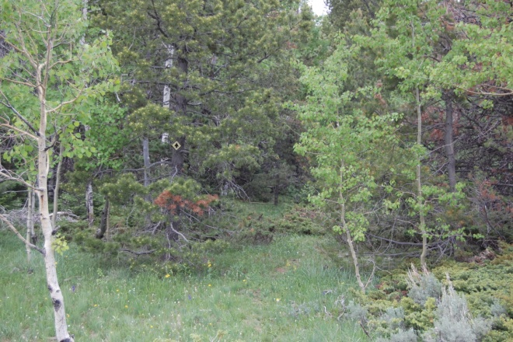
A. Snowshoe trail near start B. Snowshoe trail at Upper UW

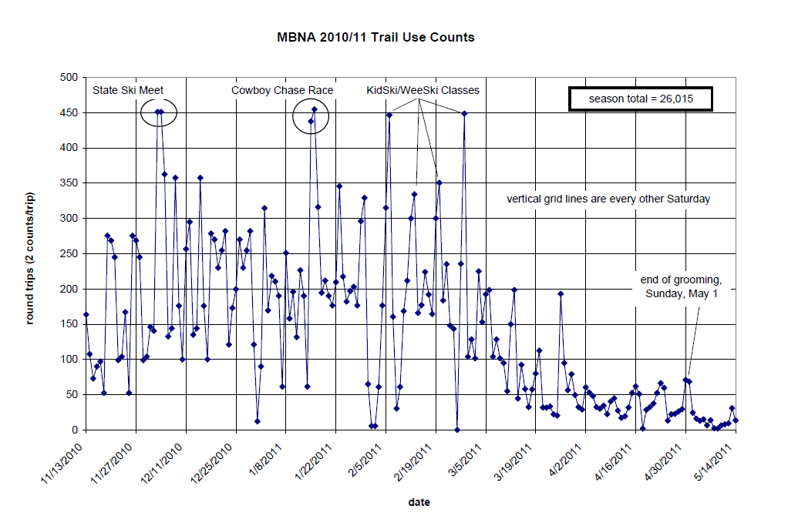

Figure 5. Daily trail use (round trips) through the season at the Tie City Trailhead. The number of round trips per day was calculated by dividing the daily counts on the trail counter by 2. This pattern of use on different days of the week, through the 2010-2011 season, is typical of ski seasons at Tie City.

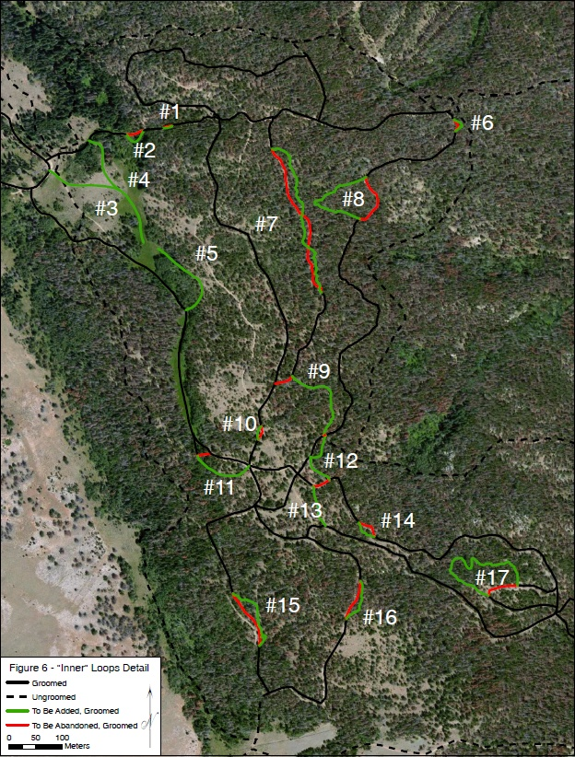
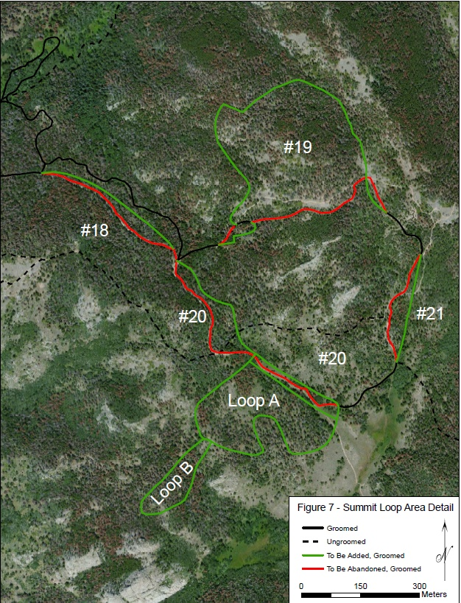
Table 1. Matrix of results from trail modifications. See section III.D of the text for explanation.

ATTACHMENT A

- 2015/16 Annual Operating Plan
- Ski Trail Map
- Multi-Use Trail Map

OPERATIONS AND MAINTENANCE PLAN 2015-2016 SEASON
MEDICINE BOW NORDIC ASSOCIATION

This Operations and Maintenance Plan implements the terms and conditions of the Challenge Cost Share Agreement #14-CS-11020605-006, dated 12/19/2013.

The purpose of this Operation and Maintenance Plan, as required by Challenge Cost Share Agreement #14-CS-11020605-006 is to display the day-to-day activities and responsibilities of Medicine Bow Nordic Association and the USDA Forest Service as it relates to the Nordic ski trails on National Forest System lands in the Laramie Ranger District, Medicine Bow-Routt National Forests. Emergencies and unplanned activities will be addressed on a case by case basis.

Designated representatives for the Medicine Bow Nordic Association are:
President: (Christi Boggs) ph. (307) e-mail christib@rocketmail.com
Coordinator: (Ellen Axtmann) ph. (307) 460-1780 e-mail eaxtmann@gmail.com
Vice President: (Bern Hinckley) ph. (307) 745-8594 e-mail bhinckley@aol.com
Secretary: (George Jones) ph. (307) 742-0056 e-mail jonesgp@vcn.com
Treasurer: (Van Jacobson) ph. (307) 760-4876 e-mail vanj@uwyo.edu

Designated representatives for the USDA Forest Service, Laramie Ranger District will be: Recreation Officer (Nathan Haynes) ph. (307)745-2317 email nhaynes@fs.fed.us
Recreation Staff Officer (Ted Benson) ph. (307)745-2390 email tedbenson@fs.fed.us

- TRAIL GROOMING AND MAINTENANCE;

Normal winter trail grooming and maintenance is the responsibility of Medicine Bow Nordic Association on those trails identified in Appendix A as “groomed”. Normal grooming and maintenance includes removal of natural and unnatural obstacles from the trail prism and maintenance of a generally smooth skate and classic ski surface by means of motorized, mechanical grooming.

The Medicine Bow Nordic Association will perform trail maintenance, as necessary, in the fall before snowfall. This maintenance shall consist of clearing fallen trees, removing rocks that have come to the trail surface during the preceding year, cutting aspen suckers and shrubs that have grown up on the trails during the preceding year, and removing other such obstructions that will prevent efficient grooming of the snow on the trails. Use of an engine-powered stump grinder will also be allowed as part of pre-season trail maintenance, as per the terms and instructions established by District Ranger Romero 8/27/15. Limited use of motorized equipment, e.g. tracked utility vehicle, will be made to support trail maintenance, including gathering debris, recovering snow fencing, delivering tools, etc.

Maintenance of groomed ski trails - the trails prism surface will be kept as free as possible of obstructions and hazards such as; fallen trees, sticks, and surface rocks. Grooming will occur from conversion of travel management from summer to winter use, i.e. from late fall, when enough snow has accumulated on the ski trails that grooming will provide an acceptable skiing surface and can be done without damage to equipment or the ground surface, until snow cover is too shallow or spotty to provide an acceptable skiing surface. The trail prism is defined as the ski travel corridor as referenced in Appendix A. It is the area that is cleared to a maximum height of 10 ft. above snow depth and two feet either side of the groomed surface. All trimmed branches within this prism will be cut flush with the tree trunk. All branches removed from trees will be scattered away from the trail. All trees that are cut will be limbed and scattered away from the trail.

To provide passage through the winter trail system, MBNA may remove sections of the fence around the Tie City campground upon the commencement of grooming and shall restore such sections promptly upon the cessation of grooming in the spring.

It is desirable that the trails will be groomed often enough to maintain a smooth skiing surface. During the normal operating season grooming will generally occur 5 to 7 days a week. Normal grooming will be done on days, and at times, determined by MBNA’s head groomer. Grooming will be timed to avoid peak use hours and reduce the impact to users. Grooming may or may not be done on a regular schedule, but will be timed to take advantage of new snowfall and wind conditions, and to maintain the existing snow surface in good skiing and in order to maximize the effectiveness of MBNA’s funding and public enjoyment of the trails.

To assist the U.S. Forest Service with management of winter recreation in the Happy Jack area, MBNA will mark, post trail maps, and occasionally pack certain of the existing “ungroomed” trails (Appendix A), as available resources and priorities accommodate. Packing with snowmobile will take place at off peak times to minimize user conflict. The snowmobile used for packing will display at all times a highly visible daylight fluorescent orange flag, fixed to a pole not less than 4’ high. Snowmobile operator is required to wear a minimum of 500 square inches of solid daylight fluorescent orange material in an outer garment above the waist.

- TRAIL INSPECTION AND PATROL FREQUENCY;

Winter inspection of the trails will be performed by Medicine Bow Nordic Association in conjunction with the routine grooming schedule. Items needing attention will be addressed during normal operations or noted and reported to the designated representative as identified in this plan.

The Forest Service will monitor the trails for compliance with the conditions of the Challenge Cost Share Agreement as needed.

The Forest Service or Medicine Bow Nordic Association will make no regularly scheduled patrols.

- USER SERVICES OPERATIONS;

The Annual operating plan, financial plan, insurance certificates, and trail map will be reviewed by the Forest Service and Medicine Bow Nordic Association each season prior to November 15th.

New maps will be printed as changes warrant and funds are available. Trails will be identified on the map, and on the ground, with a name, direction of travel, and a generalized difficulty level. Maps will include MBNA and USFS contact information, trail-use guidelines, USFS trail-use regulations, and encouragement to use the groomed and ungroomed trails appropriately.

Maps will be posted and available for viewing at the Tie City Trailhead and at major intersections within the trail system. Medicine Bow Nordic Association will fill the map dispenser at the Tie City Trailhead as funding and schedules allow.

Map production and distribution will be provided by MBNA. USFS will provide timely review and will work with MBNA to develop mutually agreeable mapping and map information.

- SIGN PLAN;

MBNA will be responsible for the installation and maintenance of a sign at the Tie City Trailhead, informing trail users of skiing and other trail use etiquette, and informing them of the role of MBNA in grooming and maintaining the trails. This sign will be erected along the trail immediately south of the Tie City parking lot, as soon as snow is deep enough to hold the sign and it will be removed soon after the end of the ski season. MBNA will also install and maintain signs at junctions in the trail system to show winter-trail users the layout of the trails. These signs will be installed at the beginning of the grooming season and removed soon after the end of the grooming season.

- Trailhead signs will be supplied, installed, and maintained by the Forest Service to notify trail users of general regulations and safety precautions.

- Individual trailheads will be marked by the Forest Service with brown Forest Service trail posts.

- Medicine Bow Nordic Association in consultation with the Forest Service will post supplemental winter-only signs and trail markers to include:

- Caution signs at unusual hazards such as steep sections of trail.

- Black arrows on white diamonds to identify one-way traffic on trails, as necessary; blue diamonds with or without arrows to mark select winter multi-use (e.g. snowshoe, snow bike) trails.

- Additional temporary trail markers and signs on race days to designate race routes. These signs will be removed after races.

- Additional signs posted to inform and regulate winter trail use, developed in coordination and with the approval of Forest Service.

- Temporary signs and markers on groomed trails will be removed by Medicine Bow Nordic Association at the end of each operating season. The signs will be stored in the MBNA storage building on the campground loop.

- STAGING AREAS:

The Forest Service shall be responsible for plowing the parking lot at the Tie City Trailhead during ski season.

The warming hut at the Tie City Trailhead and sanitary facilities are provided and maintained by the Forest Service at the Tie City Trailhead, on the Campground Loop, and at the Summit Trailhead.

- SUPPORT FACILITIES:

As authorized under a special use permit, Medicine Bow Nordic Association erected and owns a storage building located on Forest Service land on the Campground Loop.

Two elevated fuel tanks located southeast of the Campground Loop will be used to fuel grooming equipment during the ski season and will be managed to minimize off-season fuel storage.

Security and maintenance of this facility and MBNA equipment will be the responsibility of the Medicine Bow Nordic Association.

- EQUIPMENT PARKING/STORAGE:

During the ski trail grooming season, the Nordic Association’s grooming equipment will be stored in the garage attached to the warming hut at the Tie City Trailhead, inside the Campground Loop, in pullouts along the trail between the Tie City Trailhead and in the storage building on the Campground Loop. The groomers will park equipment out of the way of skiers using the trails. Outside the ski trail grooming season, grooming equipment, signs, and peripheral equipment/supplies will be stored in the storage building on the Campground Loop. Purchase and maintenance of said equipment is the responsibility of Medicine Bow Nordic Association. Medicine Bow Nordic Association will provide adequate insurance for said equipment.

- SEARCH AND RESCUE RESPONSIBILITIES AND PROCEDURES;

Search and rescue is the responsibility of the Albany County Sheriff’s Office. All reports of missing or lost persons will be made or forwarded to the Sheriff’s Office. Neither the Forest Service nor Medicine Bow Nordic Association is obligated to render assistance. The Forest Service may investigate all incidents involving serious injury, death, or extensive property damage.

Medicine Bow Nordic Association shall notify the Forest Service of any accident, injury, or missing person within 24 hours, if they are privy to this information.

The procedure to notify the Forest Service is to call or page the designated representatives during normal business hours at _______ and:
- Identify yourself
- State that you want the Forest Service to contact you and provide a contact name and number.

Attachments to 2015-2016 Medicine Bow Nordic Association Operating Plan

Appendix A: Trail Map

